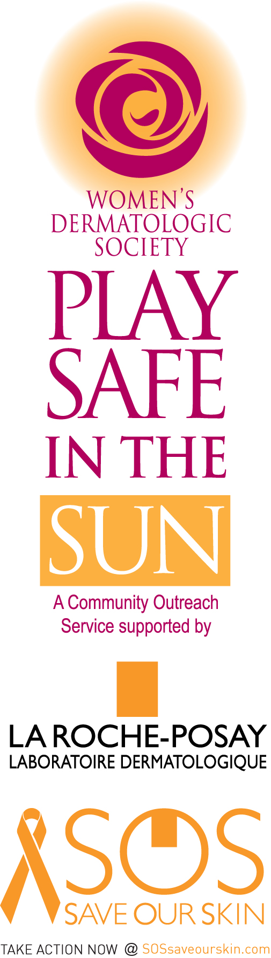
Myth or Fact? Test Your Melanoma Knowledge!

Melanoma is rare.
THIS IS A MYTH: For those born this year, 1 in 50 will develop melanoma over their lifetime.

Don't worry about melanoma; it is "just" skin cancer.
THIS IS A MYTH: Melanoma takes the life of one person every hour.

There is no effective treatment for late stage melanoma.
THIS IS A FACT: Early diagnosis of melanoma results in an 80% cure rate; therapies for later stage melanoma have varied results.

Slather on sunscreen lotion and you'll be safe in the sun.
THIS IS A MYTH: Sunscreen lotion needs to be used in conjunction with avoiding the prime solar hours of 10am - 4pm, seeking shade, and wearing protective clothing including a hat and sunglasses. Always apply sunscreen lotion frequently and heavily to exposure areas.

The amount of sunscreen you apply does not matter.
THIS IS A MYTH: You should apply one ounce to cover your entire body. This is equivalent to a golf-ball size amount or an adult hand size full.

Patients often find their own melanomas.
THIS IS A FACT: You and I find our melanomas most often and women are the champion spotters. That is why skin self-examination should be performed regularly, in addition to an annual screening by your dermatologist.

Sunburn in childhood can add up to melanoma in adulthood
THIS IS A FACT: Less than one third of children are properly protected from the sun and 80% are sunburned at least once each summer. Sunburn increases the risk of melanoma.

Melanoma does not occur in individuals with dark skin
THIS IS A MYTH: Melanoma can develop in skin of any color and in unexposed areas.

One out of three teens use tanning parlors.
THIS IS A FACT: True, and this may be the reason the rate of melanoma is rapidly rising in young women, and is the most common cancer in women age 20-29. Studies have shown the use of tanning parlors to be associated with increased melanoma incidence

Tanning beds are "artificial" sunlight, so they are a safe source of vitamin D.
THIS IS A MYTH: In fact, tanning beds do not provide vitamin D. Ultraviolet B light, which is required for the production of this vitamin, is not emitted by these artificial light sources.

Exposure to sunlight is the only way to get sufficient amounts of vitamin D.
THIS IS A MYTH: The healthiest way to get adequate levels of vitamin D is by mouth. Vitamin D supplements, vitamin D rich foods, and fortified juice or milk allow you to get the "D" benefits without increasing skin cancer risk.

Courtesy of: DuPont Guerry, IV, M.D., Director, Melanoma Program, UPENN and Catherine M. Poole, President of the Melanoma International Foundation. Sources: Melanoma International Foundation 250 Mapleflower Dr. Glenmoore, PA 19343. Women’s Dermatologic Society www.womensderm.org and www.playsafeinthesun.org

